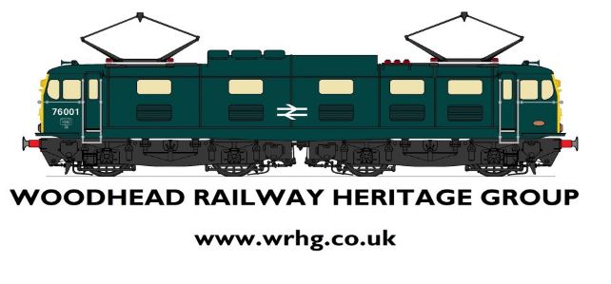

ANNUAL GENERAL MEETING
SATURDAY 7RH SEPTEMBER 2019

APOLOGIES – Paul Dennison

Agenda:
- Committee Election
- FoGBS Finances
- WRHG Finances
- Membership Update
- Museum Update
- 2020 Events
- A.O.B

- Committee Election

Position | Proposal | Seconded
Chairman | Andy Kettle | Robin Edmondson
Secretary | Vacant
Treasurer | Simon Thomas | Dean Lever
Membership Secretary | Dean Lever | Robin Edmondson
Merchandise Officer | Barry Williams | Dave Meadham
Ordinary Member #1 | Dave Meadham | Bill Pennington
Ordinary Member #2 | Colin Hodgkinson | Barry Williams

We currently have the position of Secretary vacant if anyone wishes to take up this post, if so then please contact the Chairman on 07837387060

- FoGBS Finances
FoGBS received a Grant for £500 from Stockport Council to fund the Sleepers in the Memorial Garden, the current available funds is £70
- WRHG Finances
Current availability in the account £2754-61
£117-01 was still to be paid into the account

- Membership Update

Currently we have:
50 Ordinary Members
7 Life Members

It was agreed at the meeting to increase the membership fees 01st October 2019, new fees are:
Ordinary Membership £7
Family Membership £20
Life Membership £70
New members will receive a membership card, Key Ring, Card Wallet
Renewing Memberships will receive a membership card

- Museum update
Currently we are still waiting to hear what the outcome is from the NHS utilising one of the buildings at Guide Bridge Station, a meeting has been arranged for Wed 23rd October with ACoRP and hopefully a representative from Network Rail to discuss the building plans.

- 2020 Events
After having a discussion, it has been agreed that to celebrate the 2020 events will be:

A Headboard running day: this will be having a “Woodhead 175” Headboard which will travel on the commuter services 22nd Dec 2020

A Victorian Uniform Day: this will be having volunteers dressed in Victorian costume travelling the trains handing out information Programmes dtae tbc, this will also involve the Friends of Hattersley Station, Friends of Glossop Station & Friends of Hadfield Station.

Both Simon Thomas and Andy Kettle will be holding a meeting with Keith Whitmore from the Bahamas locomotive Society – Event Details are currently not for publication

Best Of British Rail Event will take place again date tbc

- A.O.B
Del Tilling mentioned his project that he has been working and with Network Rail at Hadfield – Del has asked for this information not to be cascaded at the moment.

Meeting closed 13:30

