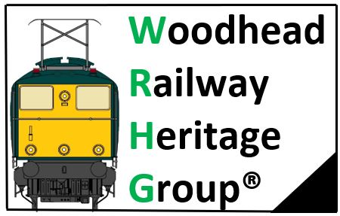

Head Office: Woodhead Railway Museum, Guide Bridge Station, Audenshaw, Tameside M34 5ZX

Annual General Meeting 2020

Date: Sunday 18th October 2020
Commenced 19:00hr and ended 20:00hr

Due to the current Coronavirus Pandemic, the meeting was held via the Skype Social media Platform.

Opening Comment
Very disappointingly we only had 5 people attend the AGM, we are aware that current COVID19 situation has prevented us from having the normal annual group meeting.

Items raised:

- Committee elect:

Chairman: Andy Kettle
Seconded Barry William's

Secretary: Vacant

Treasurer: Simon Thomas
Seconded Andy Kettle

Membership Secretary: Dean Lever
Seconded Barry Williams

Ordinarily Member: Dave Meadham
Seconded Barry Williams

2. Finances:
FoGBS- £36 in current account & £500 in reserve account, there has been no activity on this account this year

WRHG- £4800-
Balance Bank account at 31/08/19 = £2,637.60
Cash in hand at 31/08/19= £117.01
Total amount at 31/08/19 = £2754.61
Outgoing money to 01/10/20 = £140.43.
Total Income to 01/10/20 = £1947.30
Total in bank account to 01/10/20 = £4,398.17
Cash in hand as of 01/10/120 = £163.31
Total Group balance = £4561.48
Total gain = £1806.87

3. Current WRHG issues:

We had a site visit to the Museum with representatives from both Network Rail & Input the Museum Contractors, most renovation work is now complete and just snagging jobs left to complete.

The current cost of renovation work stands at £233k with a final figure yet to be met, thanks goes to Northern Trains Ltd who have funded this project.

The Lease currently being chased up and should hear within next 2 weeks, we have been informed by the Network Rail Community Manager Mr Devon Wall that we should have had the lease signed by now.

Due to the current Coronavirus pandemic, it is now looking more likely that the Museum grand opening being moved to Easter 2021, this is yet to be confirmed.

A Revised COVID19 safety working plan has been drawn up for volunteers, this is to meet the required Guidelines as set by Northern trains Ltd & Community Rail Network [CRP].

4. Current FoGBS issues:

We are currently looking for recycled items to use as planters in the Memorial garden, we do already have use of discarded tyres that have been developed in to planters.

With the Memorial garden now becoming established with foliage and with the planting of over 500 bulbs by our resident gardener Barry Williams, we will be entering the Memorial garden in to CRN 2021 small projects awards.

We are looking at the possibility to lay a Wreath for Remembrance Sunday, again pending on current Coronavirus situation
.
We have been Liaising with Network Rail to look at extending the Memorial garden under the bridge, a site visit is to be arranged in due course to look at the feasibility of using this area.

5. A.O.B:

Membership Secretary raised concerns in drop of Membership, we have put this down to current COVID19, situation and hope improve once the Museum is open.

.
Minutes compiled by Andy Kettle FdSc Chairman, Woodhead Railway Heritage Group

