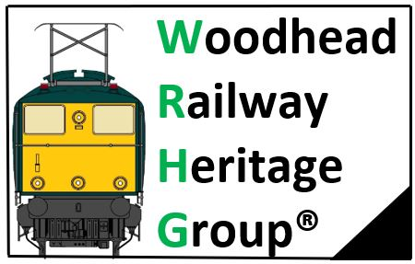

Head Office: Woodhead Railway Museum, Guide Bridge Station, Audenshaw, Tameside M34 5ZX

Annual General Meeting 2021

Date: Saturday 16th October 2021
Commenced 11:00hr and ended 12:00hr

Opening Comment
We had a good turn out now that our daily lives are getting back to some normality now the COVID19 pandemic rules are being relaxed, the meeting was held in the Woodhead Railway Museum Building at Guide Bridge Station.

Items raised:

- Committee elect:

Chairman: Andy Kettle
Seconded: Dean Lever

Secretary: Vacant

Treasurer: Simon Thomas
Seconded: Barry Williams

Membership Secretary: Dean Lever
Seconded: Dave Meadham

- Finances:

FoGBS- This account has been closed

WRHG-
Total Group Balance as of 01/10/20 = £4561,48
Current Balance in Bank account at 30/09/21 = £5,288,66
Cash in hand at 31/08/19= £253,31
Total Group Balance at 16/10/21 = £5,541,97
Total Outgoing money to 30/09/21 = £650,75
Total Income to 30/09/21 = £1,479,94
Total Gain for last 12 months =£980,49

- Membership

Our current Membership stands at 56 members and 9 Lifetime Members, we are anticipating that membership will now start to increase as we get back to some normality after the pandemic.

4. Current WRHG information:

The Committee are currently waiting for the first draft of the Lease for the Museum, there have been monthly meetings and a site visit to the Museum to discuss the outline of the lease, within the next couple of weeks we should see the first draft of the lease. We are still aiming to open the Museum Easter 2022.

We have been successful with the bid for the Dewsnap Gantry, the WRHG placed a bid and won the bidding, we are now waiting for further information from Network Rail as to when the Gantry will be made available for collection, we will need to arrange transport from the Dewsnap site to Guide Bridge Station where the Gantry will reside, once in place then a plan will be submitted for a restoration plan.

Now that COVID19 restrictions are being lifted, we do plan to start holding events again, this will include onsite events at Guide Bridge Station, and attending events with a sales stand, more information will be cascaded accordingly through our social media platforms.

5. Current FoGBS information:

Northern Trains Ltd Media Team attended Guide Bridge Station to speak to some of the volunteers for a News project for station adoption groups, two of our volunteers were interviewed and gave a talk on the Projects at Guide Bridge Station.

A new project is underway involving local schools, this project is for allotments to be developed in the spare ground to which the WRHG have a licence to work in. This is the area where the Signal Gantry will also be placed to allow people to see up close the workings of the Gantry signals. More about this Schools Project will be cascaded accordingly once we have cleared the land with the Network Rail Volunteer Team.

Earlier this year we had our first Memorial Plaque installed in the Memorial garden for one of the long serving members of staff from Guide Bridge Station, anyone wishing to have a plaque installed to get in touch with Barry Williams to which arrangements can be made.

We received a grant from Northern Trains Ltd for foliage which is now making great improvements to the station.

Our resident Painter Peter Birchill has been working tirelessly at the station, there is vast improvements with the station front, also what will be the outdoor seating area for the Museum, well worth a visit to come and see the work that has taken place.

6. A.O.B:

We have now started a Monthly ‘Mash Can Railway Club’ for anyone to attend the Museum last Saturday of each month to come and have a brew and a good natter, this club is open to anyone to attend.

.
Minutes compiled by Andy Kettle FdSc Chairman, Woodhead Railway Heritage Group

